Typed Lambda Calculus

1. Introduction
- The language of the typed lambda calculus, developed by the logician Alonzo Church, offer the tools to represent ‘unsaturated meanings’ as functions.
- The abstraction operator
- Use a variable as a placeholder in the empty slot
- An abstraction operator, written as the Greek letter λ (‘lambda’), to bind that variable, creating a function that will accept a filler for that slot.
- For example, in (1), using the λ symbol, we can abstract over the missing piece in loves(_,m) .
- λx.loves(x,m)

- Lambda Abstraction
Types
- A type is a syntactic category for an expression of the logic, but a type also represents the kind of denotation an expression has, and puts constraints on which other expressions (if any) the expression can combine with.
- Two basic types
- e: (the type of entities) for individual-denoting expressions
- t: (the type of truth values) for formulas
- we will use the term expression for any well-formed string of any type, and the term formula for any expression of type t.
- From these types we will build up function types such as
- ⟨e,t⟩: for expressions denoting functions from individuals to truth values
- The set of types is defined recursively as follows (σ ‘sigma’ and τ ‘tau’ are meta-variables that stand for arbitrary types) :
- e is a type
- t is a type
- If σ is a type and τ is a type, then ⟨σ,τ⟩ is a type.
- Nothing else is a type.
- A model associates each type with a different domain, the set of possible denotations for expressions of that type.
- D_{τ:} For any type τ, we use D_{τ} to signify the set of possible denotations for an expression of type τ.
- D_{e:} An expression of type e denotes an individual; D_{e} is the set of individuals. So we say indirectly that e is the type of individuals.
- D_{t:} An expression of type t is a formula, so its denotation must be either T or F; D_{t} = {1, 0}.

Characteristic function of this relation: | Left-to-right currying turns f into the function we call f→: | Right-to-left currying turns f into the function we call f←:
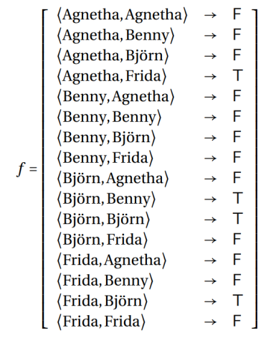 | 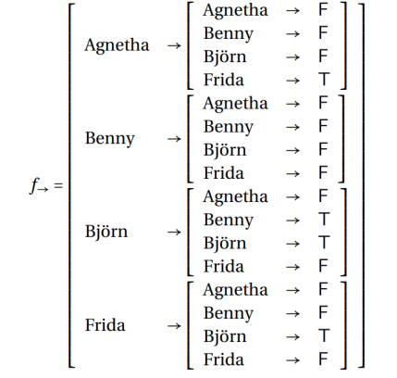 | 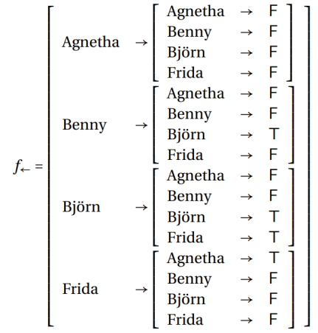

- For example, to translate the verb loves, we can use a simple expression of type ⟨e,⟨e,t⟩⟩: λy .λx .loves(x, y); λy .λx .loves(y)(x),
- loves: the initial lower case letter indicates that it is a function symbol
- loves(b): serve as the translation for the verb phrase loves Björn
- loves(b)(a): serve as the translation for Agnetha loves Björn.
- loves(a,b): also serve as the translation for Agnetha loves Björn.
Syntax and semantics of abstraction
Syntax Rule: Lambda Abstraction
- If α is an expression of type τ and u is a variable of type σ then [λu .α] is an expression of type ⟨σ,τ⟩.
- We will often drop the outer square brackets when it does not result in confusion.
- We call σ and τ the input type and output type
Semantic Rule: Lambda Abstraction
- If α is an expression of type τ and u a variable of type σ then for any assignment g, ⟦λu .α⟧^{M,g} is that function f from D_{σ} into D_{τ} such that for all objects o in D_{σ}, f (o) = ⟦α⟧^{M,g [u↦o]}
- For example, λx .happy(x) is of the form λu .α where u (i.e., x) is of type e, and α (i.e., happy(x)) is of type t. So it denotes the function f from D_{e} to D_{t} such that for all objects o in D_{e}, f (o) is equal to ⟦happy(x)⟧^{M,g [x↦o]}. For any object o, f (o) will return T (True) if o is happy, and F (False) if not. So λx.happy(x) denotes the characteristic function of the set of happy individuals.
- Application and beta reduction
Syntax Rule: Function Application
- For any types σ and τ, if α is an expression of type ⟨σ,τ⟩ and β is an expression of type σ then α(β) is an expression of type τ.
Semantic Rule: Function application
- If α is an expression of type ⟨σ,τ⟩, and β is an expression of type σ, then ⟦α(β)⟧ ^{M,g} = ⟦α⟧^{M,g} (⟦β⟧^{M,g}).
Beta reduction
- In general, the result of applying a function described by a lambda expression to an argument can be described as taking the value description and replacing all free occurrences of the lambda bound variable with the argument.
- Value description (or body): In a lambda expression of the form λx.φ, the φ part (the scope of the lambda expression) which describes the value of the function given an argument
- Free occurrences: occurrences that are not bound by another operator
- Beta reduction: [λx .φ](α) can be reduced to φ[x := α] provided that α does not contain any free variables that occur in φ.
- Here we write x for a variable of any type, α for an expression of the type of x, φ for an expression of any type, and φ[x ∶= α] for the result of replacing with α all free occurrences of x in φ
- Occurrences of the variable that are in the scope of that other variable binder are no longer bound by the lambda operator. For example, the following two formulas are equivalent:
(2) a. [λx .[smiled(x)∧ ∃x .happy(x)]](a)
b. [smiled(a)∧ ∃x .happy(x)]
- Alpha conversion: one can replace bound variables by other ones under certain conditions without a change in denotation.
- For instance, alpha conversion also allows us to convert
(3) λx .loves(x, y)
into
(4) λz .loves(z, y)
- Some applications
- Example1: the prefix non-:
- λP .[λx .¬P(x)]
- Example2: Every cellist smokes:
- The denotation of every can be represented like this:
λP .λQ .∀x .P(x) → Q(x)
- cellist is translated as follows:
λy .cellist(y)
- Then every cellist will be translated as
[λP .λQ .∀x .P(x) → Q(x)](λy .cellist(y))
- Two beta reduction:
λQ .∀x .[λy .cellist(y)](x) → Q(x);
λQ .∀x .cellist(x) → Q(x)
- Feeding it λz .smokes(z):
[λQ .∀x .cellist(x) → Q(x)](λz .smokes(z))
- two beta reductions:
[∀x .cellist(x) → [λz .smokes(z)](x)];
∀x .cellist(x) → smokes(x)

